HOUSE PRICE PREDICTION USING REGRESSION
A Project Report Submitted in the partial fulfillment of the
requirements for the award of the degree of

BACHELOR OF TECHNOLOGY
In
DEPARTMENT OF COMPUTER SCIENCE ENGINEERING

By
SOURAJA MANDAL - 2420030537
LAKSHMI SAMEERA – 2420030582
VAKA SREE - 2420030490
K.VISHNU VARDHAN REDDY-2420030063
Under the Esteemed Guidance of

LECTURE NAME

MRS. VENKATESHWARI KETINENI



K L (Deemed to be) University

DEPARTMENT OF COMPUTER SCIENCE ENGINEERING


Declaration

The Project Report entitled “House Price Prediction” is a record of Bonafide work of team members Sree– 2420030490, Souraja – 2420030537, Sameera– 2420030582, and K.Vishnu Vardhan Reddy– 2420030063, submitted in partial fulfilment for the award of B. Tech in Computer Engineering to K L University. The results embodied in this report have not been copied from any other departments/University/Institute.

Sree-2420030490
Souraja– 2420030537 Sameera- 2420030582
K.Vishnu Vardhan-2420030063

K L (Deemed to be) University DEPARTMENT OF COMPUTER SCIENCE ENGINEERING


Certificate

This is to certify that the project-based report entitled “House Price Prediction” is a Bonafide work carried out and submitted by Sree– 2420030490, Souraja – 2420030537, Sameera– 2420030582, and K.Vishnu Vardhan Reddy– 2420030063, in partial fulfilment of the requirements for the award of the degree of Bachelor of Technology in Computer Science Engineering, at K L (Deemed to be University), during the academic year 2025–2026.

Signature of the Supervisor

Signature of the HOD Signature of the External Examiner

ACKNOWLEDGEMENT
The success in this project would not have been possible but for the timely help and guidance rendered by many people. Our wish to express my sincere thanks to all those who has assisted us in one way or the other for the completion of my project.

Our greatest appreciation to my guide, K.Venkateshwari, Department of Computer Science which cannot be expressed in words for his tremendous support, encouragement and guidance for this project.

We express our gratitude to Venkateshwara rao, Head of the Department for Computer Science Engineering for providing us with adequate facilities, ways and means by which we can complete this project-based Lab.

We thank all the members of teaching and non-teaching staff members, and who have assisted me directly or indirectly for successful completion of this project. Finally, I sincerely thank my parents, friends and classmates for their kind help and cooperation during my work.

Sree-2420030490
Souraja– 2420030537 Sameera- 2420030582
K.Vishnu Vardhan-2420030063

TABLE OF CONTENTS

S.No | Contents | Page no
1 | Abstract | 6
2 | Introduction | 7
3 | Literature survey | 9
4 | Hardware and Software requirements | 12
5 | Implementation | 16
6 | Experimentation and Code | 18
7 | Results | 21
8 | Conclusion | 24
19 | References | 25

ABSTRACT
The real estate industry generates a large amount of housing data, making accurate house price prediction an important task for buyers, sellers, and real estate agencies. House prices depend on various factors such as location, size, number of bedrooms, bathrooms, parking facilities, and available amenities. Machine learning provides an efficient way to estimate property prices based on these features.

This project, titled "House Price Prediction Using Regression," develops a regression model to predict house prices using historical housing data. The dataset is preprocessed by handling missing values, removing duplicates, and converting categorical data into numerical form. A Linear Regression algorithm is then trained to learn the relationship between house features and their prices.

The dataset is divided into training and testing sets, and the model is evaluated using Mean Absolute Error (MAE), Mean Squared Error (MSE), Root Mean Squared Error (RMSE), and R² Score. Graphs such as scatter plots and actual versus predicted price charts are used to visualize the model's performance.

The results show that the regression model predicts house prices with good accuracy and reliability. This project demonstrates how machine learning can support data-driven decision-making in the real estate sector and help users estimate property prices efficiently.

INTRODUCTION

The real estate industry plays an important role in the economy, and accurately predicting house prices is beneficial for buyers, sellers, and property developers. House prices depend on several factors such as location, size, number of bedrooms, bathrooms, parking facilities, and nearby amenities. Predicting prices manually can be difficult and time-consuming.

This project, "House Price Prediction Using Regression," uses a Linear Regression model to estimate house prices based on these features. The housing dataset is preprocessed by handling missing values, removing duplicate records, and converting categorical data into numerical form before training the model.

The model is trained and tested using historical housing data, and its performance is evaluated using MAE, MSE, RMSE, and R² Score. The results show that regression is an effective machine learning technique for predicting house prices and supporting better decision-making in the real estate sector.

Problem Description and Objectives:
Problem Statement
House prices vary based on several factors such as location, area, number of bedrooms, bathrooms, parking facilities, and available amenities. Estimating the correct price of a house manually is often difficult, time-consuming, and may lead to inaccurate results. Therefore, there is a need for a machine learning-based system that can accurately predict house prices using historical housing data. A regression model can help buyers, sellers, and real estate agencies make better and more informed decisions.

Problem Description
The main objective of this project is to develop a House Price Prediction System using a Linear Regression model. The system uses a housing dataset containing features such as location, size (square feet), number of bedrooms, bathrooms, parking availability, age of the house, and amenities to predict the estimated selling price of a house.

The dataset is first preprocessed by handling missing values, removing duplicate records, and converting categorical data into numerical form. The processed data is then divided into training and testing datasets. The Linear Regression model is trained using the training data and evaluated using performance metrics such as Mean Absolute Error (MAE), Mean Squared Error (MSE), Root Mean Squared Error (RMSE), and R² Score. The developed system provides accurate price predictions, helping users make reliable and data-driven decisions in the real estate market.

LITERATURE SURVEY

The rapid growth of the real estate industry has resulted in the generation of large amounts of housing data. Predicting house prices accurately has become an important research area because property values are influenced by several factors, including location, size, number of bedrooms, number of bathrooms, parking facilities, age of the property, and nearby amenities. Traditional methods of estimating house prices rely on expert opinions and market comparisons, which are often time-consuming and may produce inconsistent results. With the advancement of machine learning, researchers have developed intelligent systems capable of predicting house prices more accurately using historical housing data.

Machine learning techniques have become increasingly popular for solving regression problems in real estate. Regression algorithms learn the relationship between input features and house prices from historical datasets and use this knowledge to predict the prices of new properties. These models help reduce human effort, improve prediction accuracy, and support better decision-making for buyers, sellers, investors, and real estate companies. The availability of large housing datasets and powerful computing resources has further encouraged the use of machine learning in property valuation.

House Price Prediction Using Machine Learning
Several researchers have proposed machine learning approaches for predicting house prices. Among the various supervised learning algorithms, Linear Regression is one of the most commonly used techniques because of its simplicity, efficiency, and interpretability. It establishes a mathematical relationship between independent variables such as location, area, number of rooms, and the dependent variable, which is the house price. Studies have shown that Linear Regression performs well when the relationship between variables is approximately linear and the dataset is properly preprocessed.

Researchers have also explored advanced regression algorithms such as Decision Tree Regression, Random Forest Regression, Support Vector Regression (SVR), Gradient Boosting, and XGBoost. These algorithms can model complex relationships among features and often provide higher prediction accuracy than simple linear models. Comparative studies indicate that ensemble learning methods like Random Forest and Gradient Boosting generally outperform traditional regression models, especially when working with large and complex datasets.

Data Preprocessing Techniques
Data preprocessing is one of the most important steps in developing a successful house price prediction model. Real-world housing datasets often contain missing values, duplicate records, inconsistent formats, and outliers that can negatively affect prediction performance. Researchers recommend handling missing values through imputation techniques, removing duplicate records, detecting outliers, and normalizing numerical features before training machine learning models.
Categorical variables such as location, furnishing status, and property type cannot be directly processed by machine learning algorithms. Therefore, encoding techniques such as Label Encoding and One-Hot Encoding are commonly used to convert categorical data into numerical form. Feature scaling methods like Standardization and Min-Max Normalization are also applied to improve model performance, particularly for algorithms that are sensitive to differences in feature scales.

Feature Selection
Selecting relevant features plays a significant role in improving prediction accuracy. Previous studies have identified several important factors that influence house prices, including property location, built-up area, number of bedrooms, number of bathrooms, parking availability, age of the building, floor level, nearby schools, hospitals, shopping centers, transportation facilities, and security services. Researchers have found that eliminating irrelevant or redundant features reduces model complexity and improves overall prediction performance.

Correlation analysis and feature importance techniques are widely used to identify the most influential variables. Correlation heatmaps provide a graphical representation of relationships between different features and the target variable, helping researchers select meaningful attributes for model development.

Model Evaluation
Model evaluation is essential for measuring the effectiveness of regression algorithms. Researchers commonly divide the dataset into training and testing subsets to evaluate model performance on unseen data. Several evaluation metrics are used, including Mean Absolute Error (MAE), Mean Squared Error (MSE), Root Mean Squared Error (RMSE), and the Coefficient of Determination (R² Score). Lower values of MAE, MSE, and RMSE indicate better prediction accuracy, while an R² Score closer to 1 indicates that the model explains most of the variation in house prices.
Cross-validation techniques have also been widely adopted to ensure that the developed model generalizes well across different datasets. These methods reduce overfitting and provide a more reliable estimate of model performance.

Data Visualization
Visualization techniques help researchers understand housing data and identify important trends. Scatter plots are used to analyze the relationship between property size and selling price, while histograms illustrate the distribution of house prices. Correlation heatmaps reveal relationships among different features, and bar charts display the importance of selected variables. Actual versus Predicted Price graphs provide a visual comparison between the model's predictions and the actual market prices, making it easier to evaluate prediction accuracy.

Comparative Studies
Several comparative studies have analyzed the performance of different regression algorithms for house price prediction. Research findings indicate that Linear Regression provides reliable results for smaller and well-structured datasets due to its simplicity and low computational cost. However, for larger datasets with complex feature interactions, advanced algorithms such as Random Forest Regression and Gradient Boosting generally achieve higher accuracy. Despite these improvements, Linear Regression remains one of the most widely used baseline models because it is easy to implement, computationally efficient, and produces interpretable results.

Conclusion
The literature shows that machine learning has significantly improved the process of house price prediction by providing accurate and efficient predictive models. Data preprocessing, feature selection, regression algorithms, and proper model evaluation all contribute to building a reliable prediction system. Based on these research findings, this project implements a Linear Regression model for house price prediction using features such as location, size, number of rooms, bathrooms, parking facilities, and amenities. The study demonstrates the practical application of machine learning in the real estate sector and highlights its potential to support better property valuation and decision-making.

HARDWARE AND SOFTWARE REQUIREMENTS

Hardware Specifications

The House Price Prediction Using Regression project does not require high-end hardware, as the machine learning model is developed and executed on a standard computer using Python. However, a basic system configuration is recommended to ensure smooth execution of data preprocessing, model training, and visualization tasks.

Processor
A system with an Intel Core i3 processor or equivalent is sufficient to run the project. For better performance during model training and handling larger datasets, an Intel Core i5 or higher is recommended.

RAM
A minimum of 4 GB RAM is required to run Python, Jupyter Notebook, and machine learning libraries efficiently. However, 8 GB RAM or above is recommended for faster execution and smooth multitasking while working with large datasets.

Storage
The project requires approximately 500 MB to 1 GB of free disk space for storing the housing dataset, Python libraries, project files, and generated outputs.
The storage is mainly used for:
- Housing dataset (CSV file)
- Python libraries and dependencies
- Generated graphs and model files
- Temporary files

Graphics
No dedicated graphics card is required. Integrated graphics available in most modern computers are sufficient since the project mainly involves data analysis, machine learning, and visualization.
Operating System
The project is compatible with:
- Windows
- Linux
- macOS
The project can be executed successfully on any operating system that supports Python and the required machine learning libraries.

Software Requirements
The project uses open-source software and Python libraries to perform data preprocessing, machine learning, and visualization.

Programming Language
- Python (Version 3.8 or above)
Python is used for data preprocessing, regression model development, prediction, and performance evaluation.
Development Environment
- Jupyter Notebook – For implementing and testing the regression model.
- Visual Studio Code (Optional) – For code editing and project development.
- Google Chrome / Microsoft Edge – For accessing Jupyter Notebook or Google Colab if required.

Libraries and Frameworks
The following Python libraries are used in the project:
- Pandas – For data loading and preprocessing.
- NumPy – For numerical computations.
- Scikit-learn – For implementing the Linear Regression model and evaluating its performance.
- Matplotlib – For plotting graphs and data visualization.
- Seaborn – For correlation heatmaps and statistical visualization.
These libraries are freely available and can be installed using the Python package manager (pip).

Visualization Tools
The following visualization techniques are used to analyze the housing dataset and model performance:
- Scatter Plots
- Correlation Heatmaps
- Bar Charts
- Actual vs Predicted Price Graphs
- Feature Distribution Charts
These visualizations help in understanding the relationship between different housing features and property prices while evaluating the accuracy of the regression model.

IMPLEMENTATION

Implementation of House Price Prediction Using Regression System

The implementation of the House Price Prediction Using Regression project focuses on developing a machine learning model that predicts house prices based on various property features. The system is designed to collect, preprocess, analyze, and train a regression model using historical housing data. The complete implementation is carried out using Python and machine learning libraries such as Pandas, NumPy, Scikit-learn, Matplotlib, and Seaborn.
The implementation process is divided into multiple stages, including data collection, data preprocessing, feature selection, model training, prediction, visualization, and performance evaluation. Each stage plays an important role in improving the accuracy and reliability of the house price prediction model.

- Data Representation and Dataset Description

The dataset used in this project consists of housing records representing real-world property information. Each record corresponds to a single house and contains various features that influence its selling price.
The dataset includes the following key attributes:
- Location – Area or city where the house is located
- Area (Square Feet) – Total built-up area of the house
- Bedrooms – Number of bedrooms
- Bathrooms – Number of bathrooms
- Parking – Availability of parking space
- Age of House – Age of the property
- Amenities – Facilities such as garden, gym, swimming pool, etc.
- Price – Selling price of the house (Target Variable)
The dataset is stored in CSV format and is loaded into Python using the Pandas library for further processing.

- Establishing the Development Environment

The implementation environment is created using Python and machine learning tools.
Python Environment
Python is used as the primary programming language for implementing the regression model. It provides powerful libraries for data analysis, visualization, and machine learning.
Development Tools
The project is developed using Jupyter Notebook or Visual Studio Code, which provide an interactive environment for writing, executing, and testing Python programs.
The required Python libraries include:
- Pandas
- NumPy
- Scikit-learn
- Matplotlib
- Seaborn
These libraries provide efficient support for data preprocessing, model development, visualization, and evaluation.

- Data Loading and Preprocessing

The housing dataset is loaded from a CSV file into a Pandas DataFrame for analysis and processing.
During preprocessing, the following operations are performed:
- Missing values are handled
- Duplicate records are removed
- Data types are validated
- Categorical variables are encoded
- Numerical features are normalized if required
- Irrelevant columns are removed
These preprocessing steps improve data quality and prepare the dataset for model training.

- Feature Selection and Model Training

Once the data is preprocessed, the most relevant features are selected for predicting house prices.
The model uses the following input features:
- Location
- Area (Square Feet)
- Bedrooms
- Bathrooms
- Parking
- Age of House
- Amenities
The target variable is:
- House Price

The dataset is divided into training and testing datasets using the Train-Test Split method. A Linear Regression algorithm is then trained using the training dataset to learn the relationship between property features and house prices.

- House Price Prediction

After training, the regression model predicts the selling price of houses based on the given input features.
The model estimates house prices using factors such as:
- Property location
- Area of the house
- Number of bedrooms
- Number of bathrooms
- Parking availability
- Age of the property
- Available amenities
The predicted values are compared with the actual house prices to evaluate the model's accuracy.

- Visualization and Result Analysis

The results of the prediction model are visualized using Python visualization libraries.
The following visualizations are generated:
- Scatter Plot showing Area vs House Price
- Correlation Heatmap of housing features
- Actual vs Predicted House Price graph
- Feature Importance Chart
- Distribution of House Prices
These visualizations help in understanding the relationship between housing features and property prices while evaluating the performance of the regression model.

- Output and Performance Evaluation

The system outputs:
- Predicted house prices
- Actual vs Predicted price comparison
- Regression model evaluation metrics
- Graphical representations of housing data
- Performance analysis of the prediction model

The performance of the model is evaluated using the following regression metrics:
- Mean Absolute Error (MAE)
- Mean Squared Error (MSE)
- Root Mean Squared Error (RMSE)
- R² Score

The results demonstrate that the Linear Regression model can accurately predict house prices based on important housing features. The developed system provides a simple, efficient, and reliable solution for estimating property prices and supports better decision-making in the real estate market.

EXPEREMENTATION AND CODE:

Code Structure

The project was implemented using Python in VS code. The code consists of the following main parts:

The project is developed using React with TypeScript to build a modern and responsive web application for predicting Hyderabad house prices. The routing is managed using TanStack Router, while Framer Motion is used to create smooth animations. The user interface is designed with Tailwind CSS and Lucide React Icons
.
The index.tsx file defines the Home page of the application. It creates the landing page, displays the project title, feature cards, navigation links, and animated components. The page introduces the AI-based house price prediction system and guides users to the prediction and analytics pages.

The features array stores information about the application's key features such as AI Prediction, Market Analytics, Fast Results, and Explainable AI, which are dynamically displayed on the homepage

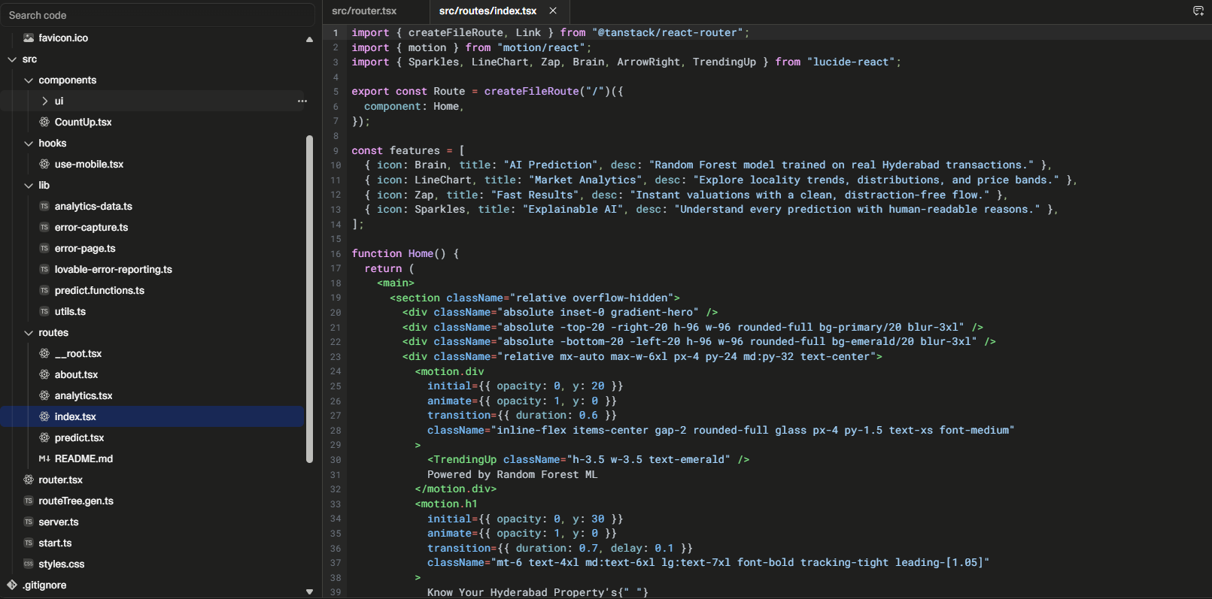.

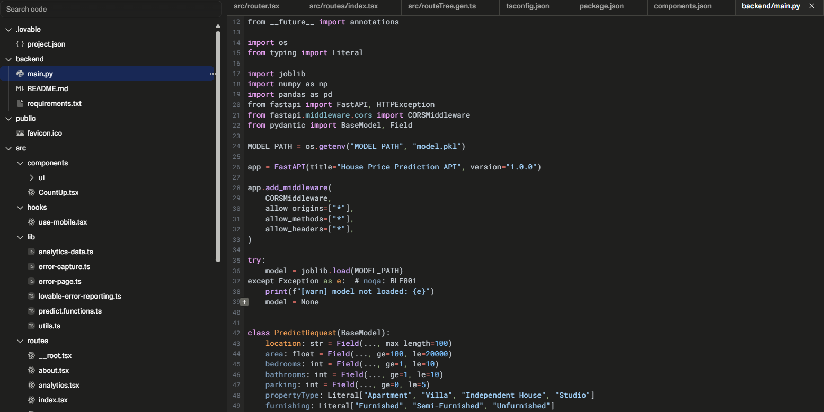

Experimentation

Steps Performed
- Designed the frontend using React and Tailwind CSS.
- Created multiple pages using TanStack Router.
- Implemented responsive UI components with reusable React components.
- Added animations using Framer Motion for improved user experience.
- Developed a prediction form to collect property details.
- Connected the frontend to the FastAPI backend.
- Loaded the trained Random Forest model (model.pkl) in the backend.
- Sent user inputs to the backend through REST APIs.
- Generated house price predictions based on the Hyderabad Housing Dataset.
- Displayed prediction results, analytics charts, and AI explanations on the frontend.

Conclusion of Experimentation

The experiment successfully demonstrates the implementation of a Machine Learning-based House Price Prediction System using the Hyderabad Housing Dataset. A Random Forest Regression model is integrated with a modern React frontend and FastAPI backend to provide accurate and user-friendly property price predictions.
The application effectively combines machine learning, web development, and data visualization to help users estimate property prices and understand market trends. The project achieves its objective of delivering an interactive, reliable, and scalable house price prediction platform suitable for educational and real-world applications.


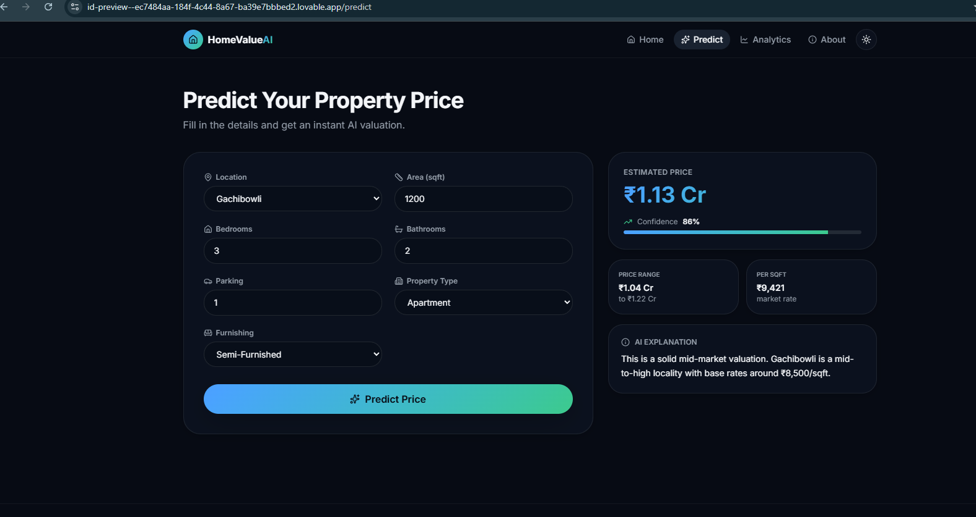

RESULT

Results of the House Price Prediction Using Regression Project

The implementation of the House Price Prediction Using Regression system produced meaningful results that demonstrate the effectiveness of machine learning in predicting housing prices based on various property features. The project successfully analyzed housing data, performed data preprocessing, trained a Linear Regression model, and predicted house prices with good accuracy. The obtained results highlight the usefulness of regression techniques in assisting buyers, sellers, and real estate agencies in making informed decisions.

House Price Prediction Analysis

The system analyzed the housing dataset to understand the relationship between different property features and house prices. The following observations were obtained:

Houses located in prime locations had higher selling prices than those in less developed areas.

Properties with larger built-up areas generally had higher market values.

Houses with more bedrooms, bathrooms, parking facilities, and modern amenities showed increased selling prices.

These observations demonstrate that machine learning can effectively identify the factors that influence house prices.

Regression Model Prediction

One of the major objectives of the project was to accurately estimate house prices using a regression model. The prediction was performed using important housing features such as:

Location

Area (Square Feet)

Number of Bedrooms

Number of Bathrooms

Parking Availability

Age of House

Amenities

The Linear Regression model successfully learned the relationship between these features and house prices, producing reliable predictions for unseen data.

Performance Evaluation

Prediction Accuracy

The performance of the Linear Regression model was evaluated using standard regression metrics.

The evaluation metrics included:

Mean Absolute Error (MAE)

Mean Squared Error (MSE)

Root Mean Squared Error (RMSE)

R² Score

The model achieved satisfactory prediction accuracy, indicating that Linear Regression is suitable for estimating house prices based on historical housing data.

Efficiency

The prediction model required very little computation time and produced results quickly, making it suitable for real-world applications.

Visualization and Insight Generation

Data visualization played an important role in understanding the housing dataset and evaluating the model's performance.

The following visualizations were generated:

Scatter Plot showing Area vs House Price

Correlation Heatmap of housing features

Actual vs Predicted House Price graph

Distribution of House Prices

Feature Importance Chart

These visualizations helped identify relationships among housing features and demonstrated the prediction accuracy of the regression model.

Machine Learning-Based Observations

A Linear Regression algorithm was implemented to predict house prices using the selected housing features.

The model successfully:

Predicted house prices with good accuracy.

Learned the relationship between housing features and property values.

Demonstrated the practical application of machine learning in real estate price prediction.

Although a simple Linear Regression model was used, the results showed that machine learning can effectively estimate property prices and support data-driven decision-making.

Learning Outcomes

Through this project, the following key learnings were achieved:

Understanding of supervised machine learning and regression algorithms.

Practical experience with Python and Scikit-learn.

Knowledge of data preprocessing and feature engineering.

Hands-on experience with housing data analysis.

Understanding the importance of model evaluation using MAE, MSE, RMSE, and R² Score.

Experience in data visualization using Matplotlib and Seaborn.

Final Overview

The results of the project clearly demonstrate that machine learning provides an efficient and reliable approach for house price prediction. The Linear Regression model successfully predicted housing prices using important property features such as location, area, bedrooms, bathrooms, parking facilities, age of the house, and amenities.

The project successfully achieved its objectives by implementing a regression model capable of estimating house prices with good accuracy. The outcomes highlight the importance of machine learning in the real estate sector and provide a strong foundation for future improvements, such as using advanced regression algorithms, larger datasets, and real-time housing market information.

CONCLUSION

The House Price Prediction Using Regression project successfully demonstrated how machine learning can be used to estimate house prices accurately based on various property features. By using Python, Pandas, NumPy, Scikit-learn, Matplotlib, and Seaborn, the project provided an efficient and practical solution for predicting housing prices.

Through the implementation of data preprocessing techniques, feature selection, and a Linear Regression model, the system successfully learned the relationship between important housing features such as location, area, number of bedrooms, bathrooms, parking availability, age of the house, and amenities. The model produced reliable price predictions and was evaluated using Mean Absolute Error (MAE), Mean Squared Error (MSE), Root Mean Squared Error (RMSE), and R² Score, which demonstrated its effectiveness.

The project also included various visualization techniques such as scatter plots, correlation heatmaps, and actual versus predicted price graphs to better understand the housing dataset and evaluate the model's performance. These visualizations made it easier to interpret the influence of different property features on house prices.

Overall, the project successfully achieved its objective of developing a regression-based house price prediction system. It demonstrates how machine learning can support buyers, sellers, and real estate agencies in making informed decisions based on data analysis. The project also provides a strong foundation for future enhancements, such as implementing advanced regression algorithms like Random Forest Regression, Decision Tree Regression, or XGBoost and incorporating real-time housing market data to improve prediction accuracy.

REFERENCES

References

Python Official Documentation

Python Software Foundation. Python Documentation.

Available at: https://docs.python.org/3/

This reference was used for Python programming concepts and data handling techniques.

2. Scikit-learn Documentation

Scikit-learn Developers. Machine Learning in Python.

Available at: https://scikit-learn.org/

This source was used for implementing the Linear Regression model and evaluating its performance.

3. Pandas Documentation

The Pandas Development Team.

Pandas User Guide.

Available at: https://pandas.pydata.org/docs/

This reference helped in data preprocessing, cleaning, and manipulation.

4. NumPy Documentation

NumPy Developers.

NumPy User Guide.

Available at: https://numpy.org/doc/

Referenced for numerical computations and array operations.

5. Matplotlib Documentation

Matplotlib Development Team.

Matplotlib Documentation.

Available at: https://matplotlib.org/

Used for generating graphs and visualizations.

6. Seaborn Documentation

Seaborn Developers.

Statistical Data Visualization.

Available at: https://seaborn.pydata.org/

Used for creating correlation heatmaps and statistical plots.

7. Géron, A. (2019)

Hands-On Machine Learning with Scikit-Learn, Keras, and TensorFlow.

O'Reilly Media.

This book provided concepts related to machine learning algorithms and regression techniques.

Online References

https://scikit-learn.org/

https://pandas.pydata.org/

https://numpy.org/

https://matplotlib.org/

https://seaborn.pydata.org/

https://www.kaggle.com (for housing datasets)

https://www.geeksforgeeks.org (for Python and Machine Learning reference)

